DEEP IN MY SOUL
BIG DADDY WILSON
TRACKLIST

001 | I Know | 00:03:12
002 | Ain't Got No Money | 00:03:15
003 | Mississippi Me | 00:03:35
004 | Tripping On You | 00:04:25
005 | I Got Plenty | 00:04:08
006 | Hold On To Our Love | 00:03:15
007 | Deep In My Soul | 00:04:38
008 | I’m Walking | 00:04:16
009 | Crazy World | 00:05:23
010 | Redhead Stepchild | 00:04:06
011 | Voodoo | 00:03:21
012 | Couldn‘t Keep It To Myself | 00:00:49

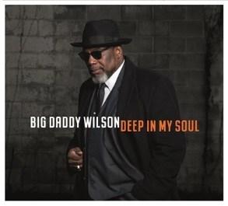
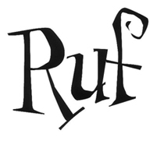
Ruf 1259
Barcode: 710347125921
Release Date: 19th April 2019

The American South casts a powerful spell. The sons and daughters of those deep states might stray from their hometowns, make their fortunes and families overseas. But wherever they roam, the South is there under their skin – and one day it will call them home. So it was with Deep In My Soul: the album that lured Big Daddy Wilson from his base in Europe back to the US motherland. “It was like a homecoming,” he says. “To take it back home like this, back to my roots, was very sweet and special.”
Released in 2019 on Ruf Records, Deep In My Soul marks a triumphant US return for the North Carolina-born bluesman, who made his name on the European scene with acclaimed albums like Love Is The Key (2009) Thumb A Ride (2011), I’m Your Man (2013), Time (2015) and 2017’s Neck Bone Stew. The seeds of this new album were sown in May 2018, when Wilson travelled to Memphis, Tennessee, for preproduction alongside respected guitarist Laura Chavez and rock-steady bassist Dave Smith. And all the pieces fell into place when the bandleader started work with Grammy-winning producer Jim Gaines at his Bessie Blue Studios in Stantonville.
Completing the album at the iconic FAME Studios in Muscle Shoals, Alabama, Wilson was aware of walking in the footsteps of the greats. But even in a recording facility that once hosted titans from Etta James to Duane Allman, these new songs measured up. There’s the brassy soul of I Know. The heartfelt ripple of Mississippi Me. Wilson takes us from the rubberband funk of Tripping On You and the reggae-flavoured I Got Plenty to the funky wah-driven Voodoo and the slow-burn atmosphere of Crazy World. “Normally, I go with the acoustic vibe,” he explains. “But I was shooting for a soulful, more electric vibe with a band on this one.”
As for Wilson’s lyrics, Deep In My Soul addresses love in all its forms: “Voodoo is about a holy man who don't believe in voodoo, but this woman got some type of hold of him that he can't break free from. Hold On To Our Love is about a mixed couple trying to hold on to the love of their life despite the pressure from this world. I Know is when you found the love of your life, everything inside of you tells you that, no doubt about it. So you see – it’s all about love. It’s always about love.”
Some things change. Others stay the same. And with Deep In My Soul, Big Daddy Wilson’s music and career come full-circle in style. “I see it as a journey,” he says of his incredible backstory. “It’s the journey of a man who found himself deep in this beautiful music called the blues and finally, after 25 years, made it back home…

